THEME: (please keep one item)
• Contribution and challenges of PBM in practical / novel applications
• Identification and uncertainty analysis of PBM
• Experimental approaches, monitoring
• Solution methods of PBM, stochastic PBM
• Multiscale coupling of PBM

- Are you interested in publishing a full-length article in Chemical Engineering Research and Design: Yes, No, Don't know yet

This is the title of the abstract

First Name Last Name ¹ – First Name Last Name² – First Name Last Name^{1,2}
¹ Affiliation of the author (Institute, Department, Address of the institute).
²University of Lyon, LAGEPP UMR 5007, 69622 Villeurbanne, France.

The abstract length can be 2 to 4 pages. Maximum number of pages for the abstract is 2+2, i.e., 2 page for abstract writing and 2 page for Figures and Tables.

The references can be sited in the text as follows (Lebaz and Sheibat-Othman 2019) [1]. The reference style of the figures and tables is Figure 1 and Table 1 respectively.

This 7th International Conference on Population Balance Modelling (PBM 2022) aims to bring together researches from academia and industry to exchange about the recent progresses in the various fields employing population balances.

This series of International Conferences on Population Balance Modelling was initiated in 2000, to respond to the increasing demand to meet and exchange about population balances, developments and solutions, in different fields. Six conferences took place, first at Kona (Hawaii, 2000), followed by Valencia (Spain, 2004), Quebec (Canada, 2007), Berlin (Germany, 2010), Bangalore (India, 2013), and Gent (Belgium, 2018). These conferences have stimulated the increasing interest to pursue its organisation. Due to the Covid-19 crisis, it could not be organised in 2021 and was postponed to 2022.

The conference covers the different application fields of population balances, including pharmaceutical and chemical processing industry, medical applications or biological systems. It is aimed to exchange about the elaboration of population balances in the different fields, recent solution and simulation strategies, adaptation to complex multivariate systems, employment in optimisation and control strategies, etc.

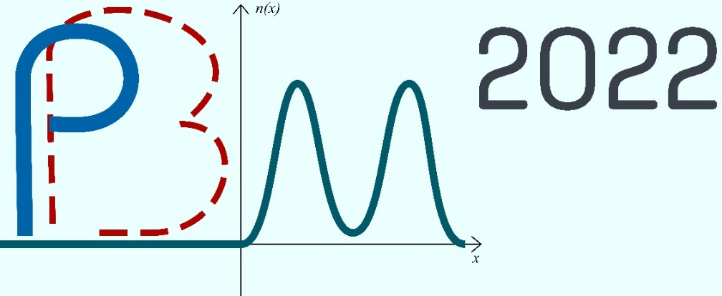
Figure 1: PBM2022 logo.

Table 1: Information of different events.
Events | Dates
Opening submission system | September 20, 2021
Abstract submission deadline | December 15, 2021

References
[1] N. Lebaz, N. Sheibat-Othman, A population balance model for the prediction of breakage of emulsion droplets in SMX+ static mixers, Chem. Eng. J. 361 (2019) 625–634. https://doi.org/10.1016/j.cej.2018.12.090.

