This is the abstract template for ICTAC-2021 online conference
(Microsoft Word, “.docx” format)
– March 3rd 2021 –

Please respect the following guidelines and delete them before submission in order to keep a one-page document.

Please submit your abstract as a single document with Microsoft Word “.docx” format including the graphic if so. The name of the document should be specified as follows:

“FAMILYNAME_FirstName_ictac2021.docx”

Example : “SMITH_Paul_ictac2021.docx”

First and family names should refer to the researcher who submits the abstract (not necessarily to the one who will present the results).

N.B.:
(1) All the text is written in English.
(2) Please respect the one-page limit for the complete abstract.
(3) Please respect the page margins (2.5 cm: top, bottom, left and right).
(4) Please respect all the stylistic guidelines appearing in gray all along the template and delete them before submission. Delete also the proposed text not appearing in gray and indicated as an example.
(5) Blank lines should be all identical with Font = Times New Roman, Size = 12pt.
(6) For the color graphic, please respect the maximum size and resolution indicated in the corresponding frame and replace the frame by your illustration.

Title of the Abstract
[Font = Times New Roman, Size = 14 pt, Style = Bold, Text = Centered, Color = Black]

Author #1’s First Name Family Name,^{1,2,3} Author #2’s First Name Family Name,^{3,4} etc… Author #N’s First Name Family Name^{1,4,N,*}
[Font = Times New Roman, Size = 12 pt, Style = Regular, Text = Centered, Color = Black]
[Affiliation markers should be superscripted; a star identifies the author who submits the abstract with the email, while an underlined name defines the author who presents the results]

¹ Affiliation #1 [Font = Times New Roman, Size = 10pt, Style=Italic, Text = Centered, Color = Black]
² Affiliation #2 [Font = Times New Roman, Size = 10pt, Style=Italic, Text = Centered, Color = Black]
^{N} Affiliation #N [Font = Times New Roman, Size = 10pt, Style=Italic,Text = Centered, Color = Black]
* Email : paul.smith@lab.com [Font=Times New Roman, Size=10pt, Style=Italic, Text=Centered,Color=Black]

Write here your abstract as a plain text composed of 15 lines maximum if you insert a graphic and 30 lines maximum if not. Three references can be marked with brackets [ ] and numbered.
[Font = Times New Roman, Size = 12pt, Style = Regular, Text = Justified, Color = Black]
[Font = Times New Roman, Size = 12pt, Style = Regular, Text = Justified, Color = Black]
[Font = Times New Roman, Size = 12pt, Style = Regular, Text = Justified, Color = Black]
[Font = Times New Roman, Size = 12pt, Style = Regular, Text = Justified, Color = Black]
[Font = Times New Roman, Size = 12pt, Style = Regular, Text = Justified, Color = Black]
[Font = Times New Roman, Size = 12pt, Style = Regular, Text = Justified, Color = Black]
[Font = Times New Roman, Size = 12pt, Style = Regular, Text = Justified, Color = Black]
[Font = Times New Roman, Size = 12pt, Style = Regular, Text = Justified, Color = Black]
[Font = Times New Roman, Size = 12pt, Style = Regular, Text = Justified, Color = Black]
[Font = Times New Roman, Size = 12pt, Style = Regular, Text = Justified, Color = Black]
[Font = Times New Roman, Size = 12pt, Style = Regular, Text = Justified, Color = Black]

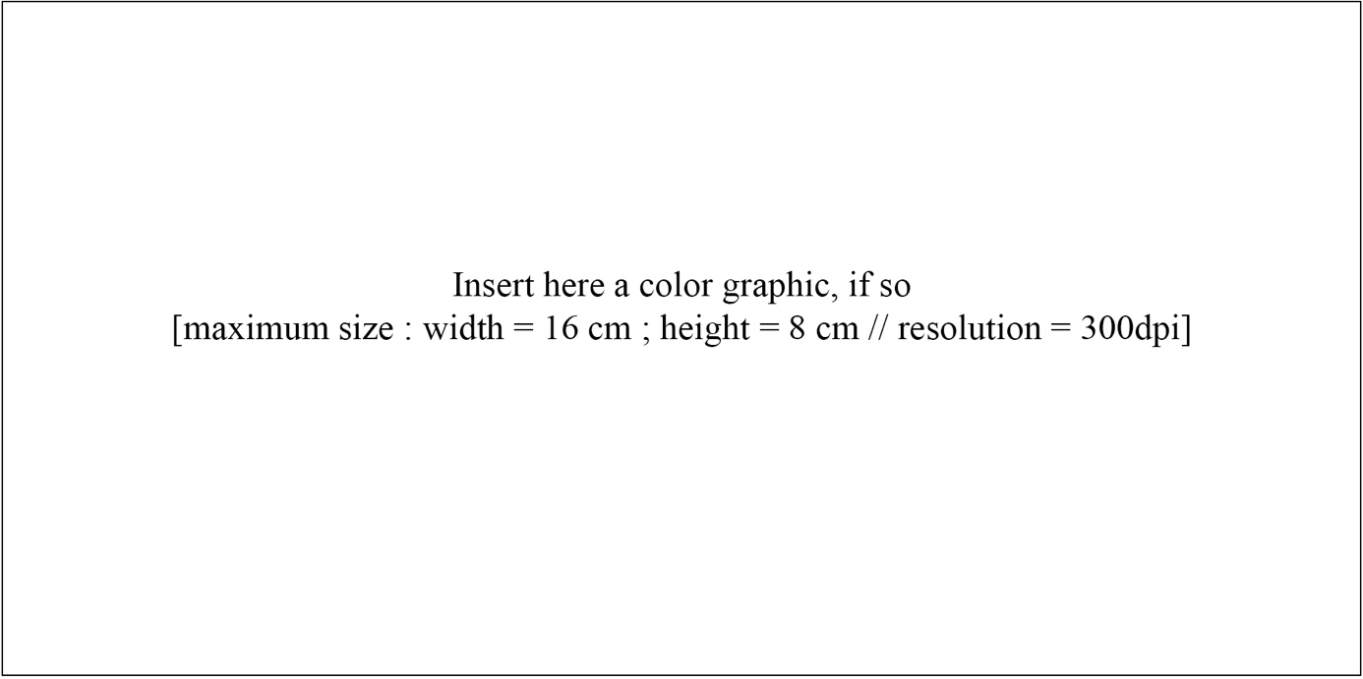
Write here the caption of the graphic if so, as a short plain text composed of 2 lines maximum [Font =Times New Roman, Size = 10pt, Style = Regular, Text = Justified, Color = Black]

Three references maximum can be placed here as follows:
[1] Reference #1…[Font = Times New Roman, Size = 10pt, Style = Regular, Text = Justified, Color = Black]
[3] Reference #3 [Font = Times New Roman, Size = 10pt, Style = Regular, Text = Justified, Color = Black]

