Abstract submission Form – ANGEL2018
----------------------------------------- FILE SUBMISSION -----------------------------------------
The abstract form contains an information page and an abstract page.
Please submit your abstract form online before February 5th, 2018
The abstract file in WORD format (.doc or .docx) has to be sent to abstract-ANGEL2018@univ-lyon1.fr (file less than 10 MB are mandatory)
The subject of the message should begin with “Abstract, followed by the surname of the presenter”. Please rename this file into: “Name of the presenting author.docx”. If there is more than one abstract from the same author, the name of the author should be followed by a corresponding number (maximum 2).
-------------------------------- PREFERED PRESENTATION TYPE --------------------------------
☐poster presentation only
☐poster presentation with a contribution to the special session "flash talks for posters".
☐oral communication
☐invited speaker
Note: 30 slots are available in the special session "flash talks for posters". Priority shall be given to the students)
---------------------------- PRESENTING AUTHOR INFORMATION ----------------------------
Title (BSc, MSc, Dr, Prof …):
First name (given name):
Last name (surname):
Affiliation:

Email address:
☐I’m a student (Master student or PhD student).
----------------------------------------- GUIDELINE -----------------------------------------
Please see below

Template for ANGEL2018 Abstract
(18 Point, Centred and Bold, Times New Roman)

A. Author¹, B. Author², C. Author³
(List of authors in 10 point, centred and bold: the presenting author is the underlined)
1- The author affiliation and full address should be located here in 8 point, centred and in italics
2- Address of author² if different
3- Address of author³ if different

Main author email address: in 10 point, centred and in italics

The abstract must be written in English. The abstract will be distributed in an electric file. There will be no formatting done to the abstract prior to publication in the abstract book. Therefore it is very important to ensure that your abstract follow the style guide presented in this template in order to provide a uniform and consistent appearance. Abstract should not exceed one page in length. The dimension of the paper is A4 size paper: 210mm x 297mm. Margins should be 25.4 mm on all sides, and the text should be written in 10 point Times New Roman (and Symbol, if necessary).
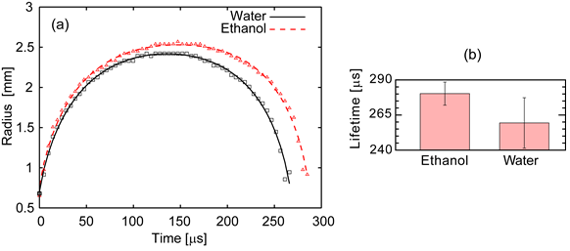
Figure 1 Captions in 8 point form. (a) The figure, as well as each axis coordinates and titles must be large enough to be easily read. (b) Any micrographs being used should have very good contrast in order to ensure proper visibility. The font of text in the figures should be Arial (and Symbol, if necessary).

A couple of Figures/Tables may be included to the abstract. Large figures should be centred as shown in the Figure 1, and small ones may be placed side by side. In all cases, the figures must be located completely inside the paper margins. Figure captions, in 8 pt, should be positioned in centre below the figures as shown in Figure 1. Table captions, also in 8 pt, should be positioned centred above the tables.
All references should numbered and appear at the end of the abstract in the same order as used in the text. The font should be the same as the main body of the text but with an 8 pt size. Reference should be aligned to the left. In the main body of the text, the reference designation should be with square brackets [1], and several references can be included together using a comma [2, 3]. If three or more consecutive references occur together, a dash is to be used [1-3].
The abstract must be submitted in a WORD format (.doc or .docx). The size of the file should not exceed 10 MB because of the system limitation (if you cannot fit to this, please contact to abstract-ANGEL2018@univ-lyon1.fr before submission). It would be emphasized again that the fonts used in the file should be only Times New Roman, Arial, and Symbol in both text and figures.
Note that one figure and at least 3 references are mandatory.
[1] A. Author and B. Author, Title of paper, Journal Name, vol., pp. startpage-endpage, (year).
[2] A. Author, B. Author, C. Author, Title of paper, Journal Name, vol., pp. start-end, (year).
[3] A. Author, Title of book (Publisher), Chapter, (year).

