Title (Times, 14 bold)

1st Author,ª 2nd Author,ª 3rd Author^{b,}* (Times 12 bold)
ªAuthor’s affiliation, City, Zip code, Country (Times 10 Italic)
^{b}Author’s affiliation, City, Zip code, Country (Times 10 Italic)
*Corresponding author: E-mail address (Times 10 Italic)

(((You can directly use this template without changing the format. The length of the abstract is limited to 2 pages including figures and tables with a top margin of 25 mm and side and bottom margins of 20 mm. The main text should be divided into four sections: Introduction, Experimental, Results and discussion, and Conclusions. All bibliographical references should be superscripted numerals (starting from ¹) in the text, and listed in the References section. Convert your Word file to PDF file and submit the PDF file on the CatBior2017 website. Please note that the final pdf file to be uploaded should not exceed the size limit of 2MB.
Please select your preferred presentation form among the three proposed forms: “Oral Preferred Poster Accepted (OPPA)” or “Oral Only (OO)” or “Poster Only (PO)” and name your PDF file in one of the three ways:
Surname_Firstname_OPPA.PDF
Surname_Firstname_OO.PDF
Surname_Firstname_PO.PDF )))

1. Introduction (Times 11 bold)
The organizing committee cordially invites you to attend the 4th International Congress on Catalysis for Biorefineries, Catbior 2017, to be held in Lyon (France) from 11 to 15 December 2017. The 1st Catbior originated in 2011 in Málaga (Spain). Since then, the congress alternates worldwide in odd years: the 2nd congress was held in Dalian (China) in 2013, the 3rd one took place in Rio de Janeiro (Brazil) in 2015. (Time 11)

2. Experimental (Times 11 bold)
This fourth edition will address the main issues in the dynamic field of catalysis for biorefineries, in fundamental and applied catalysis researches for biomass transformation. Special emphasis will be placed on the utilization of lignocellulosic or algal biomass and non-edible vegetable oils, which do not compete with food. It will be focused on the use of sustainable catalytic methodologies, heterogeneous and homogeneous, including hybrid or dual catalysis. (Time 11)

3. Results and discussion (Times 11 bold)
The topics of interest include:
1) Catalytic routes for direct polysaccharides, lignin, and raw biomass transformation.
2) Catalytic transformation of lignocellulosic platform chemicals.
3) Catalytic transformation of vegetable oils, fats, algae and oleo-derived chemicals.
4) Thermochemical transformations of biomass into bio-oils and related catalytic upgrading technologies for bio-oils.
5) Modeling aspects of the processes and mechanistic studies.
6) Development of analytic tools, in situ characterization techniques. (Time 11)

Preliminary Program:
The program of the "4th International Congress on Catalysis for Biorefineries” (Catbior 2017) will include 4 plenary lectures, 6 keynotes lectures in addition to orals/posters communications.
Moreover, three Industrial symposia are scheduled with invited speakers, on the following topics:
1- Starch, sugar, wood industries: past and future
2- Biomass to chemicals
3- Biomass to biofuels (Time 11)
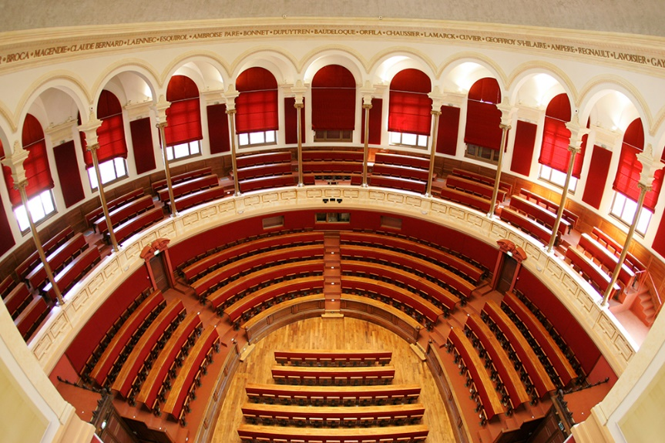
Figure 1. The amphitheater of the CatBior2017 congress (Times 9).

The program of the "4th International Congress on Catalysis for Biorefineries” (Catbior 2017) will include 4 plenary lectures, 6 keynotes lectures in addition to orals/posters communications. (Time 11)

Table 1. The invited speakers (Times 9).
Plenary Speakers (Time 10 bold) | Keynote Speakers
Pr Johannes LERCHER (Time 10) | Pr Bert SELS
Pr Matthew NEUROCK | Pr Fabrizio CAVANI
Pr Atsushi FUKUOKA | Pr Agnieszka RUPPERT
Pr Yanqin WANG | Pr Jose Antonio LOPEZ-SANCHEZ
 | Pr Pieter BRUIJNINCX
 | Pr Friederike C.JENTOFT

Moreover, three Industrial symposia are scheduled with invited speakers, on the following topics:
1- Starch, sugar, wood industries: past and future
2- Biomass to chemicals
3- Biomass to biofuels (Time 11)

4. Conclusions (Times 11 bold)
We are looking forward to welcoming you in Lyon for this international event and to sharing with you the latest scientific progresses in the area of catalysis for biorefineries. (Time 11)

References (Times 11 bold)
1. A.B. Starch, C.D. Sugar, E.F. Wood, Green Chem. 4 (2017) 1112-1512. (Times 9)

